UNIVERSITY OF MORATUWA
Faculty of Engineering

Registered Module No:MT 3993 – Industrial Training
Industrial Training Report
Consulting Engineering and Contractors (Pvt) Ltd
From: 05/12/2024 to 23/05/2025

Date of Submission:
25/07/2025

Premakumara H.P.S.
210494D

Department of Materials Science and Engineering
Preface
The field of Materials Science and Engineering plays a critical role in ensuring the safety, quality, and long-term sustainability of civil infrastructure. As a student of the Department of Materials Science and Engineering at the University of Moratuwa, I had the opportunity to undergo a six-month industrial training program at Consulting Engineering and Contractors (Pvt) Ltd, under the supervision of the Sri Lanka Road Development Authority (RDA). This internship allowed me to bridge the gap between academic learning and real-world engineering practice within the context of a nationally significant rural road construction project.
The internship was carried out over a 24-week period and was structured into four progressive stages, each designed to expose me to the technical, managerial, and practical aspects of road development. I began with core field and laboratory investigations—such as Dynamic Cone Penetration (DCP) tests, Proctor compaction, and sieve analysis—which laid the foundation for understanding soil behaviour and subgrade performance. The second stage deepened my knowledge in material sourcing, borrow pit evaluation, and laboratory testing on aggregates, leading to a broader appreciation for quality control in road construction materials.
Subsequent stages focused on more advanced technical work, including pavement design, compaction verification using field density tests, and participation in concrete works involving mix design, slump testing, and cube casting. In the final phase, I was involved in bitumen testing, asphalt mix validation, and on-site asphalt laying trials. A special highlight was conducting a research study focused on the feasibility of reducing asphalt thickness as a cost-saving and performance-optimized measure, a task that connected both technical analysis and practical field evaluation.
This report captures the full scope of my internship experience—documenting technical responsibilities, professional interactions, and personal development. The training enhanced my practical understanding of materials testing, construction workflows, and site-level decision-making, while also sharpening my problem-solving, documentation, and teamwork skills.
I consider this internship an essential milestone in my academic and professional journey, one that has meaningfully prepared me for a future career in the field of civil and materials engineering.

Acknowledgement
I would like to thank all the people and organizations who helped and supported me during my industrial training. This internship was a very important part of my university education, and I am truly grateful to everyone who made it a meaningful and valuable experience.
First, I would like to thank the National Apprentice and Industrial Training Authority (NAITA) and the Industrial Training Division of the University of Moratuwa for arranging this training opportunity and for their support throughout the internship period. I also want to thank the Department of Materials Science and Engineering, especially Senior Lecturer S. P. Guluwita, for guiding me through both academic and training work.
I am very thankful to Consulting Engineering and Contractors (Pvt) Ltd for giving me the chance to complete my training with them. The support I received from the engineers, technical officers, and laboratory staff helped me learn a lot about construction work and materials testing. I was able to get real-world experience through their advice and assistance, both at the site and in the lab.
I especially thank my supervisors and the site engineers for giving me useful feedback and encouraging me to take part in many important activities such as soil testing, bitumen and asphalt work, pavement design, and compaction testing.
Finally, I would like to thank my family and friends for their continuous support and encouragement during this journey. Their belief in me gave me the strength to do my best throughout the training period.
This experience has helped me grow in many ways, and I am truly grateful to everyone who made it possible.

Table of Contents
1. Description of the Organization 8
1.1. Vision and Mission 9
1.2. Organizational Structure 9
1.3. Company Facilities and Equipment 10
1.4. Project Portfolio 10
1.5. Health, Safety, and Environmental (HSE) Policy 12
2. Familiarization Work & Experiences 12
2.1. Initial Familiarization & Support Systems 12
2.1.1. Orientation and Site Introduction 13
2.1.2. Exposure to Internal Systems 13
2.1.2.1. Health, Safety, and Environment (HSE) 13
2.1.2.2. Logistics and Administration 14
2.1.2.3. Laboratory Equipment Calibration 15
2.1.3. Familiarization with Field Testing Procedures 15
2.2. Technical Work and Hands-on Training 16
2.2.1. Soil Investigations and Testing 17
2.2.2. Material Management and Sourcing 18
2.2.3. Asphalt and Concrete Mix Design 19
2.2.4. Quality Control and Site Compaction Testing 20
2.2.5. Bitumen and Aggregate Testing 21
2.2.6. Daily Engineering Routines 22
2.3. Soft Skills, Documentation & SWOT Analysis 22
2.3.1. Communication and Collaboration 23
2.3.2. Use of Digital Tools and Documentation 23
2.3.3. Self SWOT Analysis 24
2.3.4. Organizational SWOT Analysis 25
3. Conclusion 26
3.1. Reflection on Internship Experience 26
3.2. Areas for Improvement in the Internship Process 26
3.3. Self-Assessment and Growth 27
4. References 28

Table of Figures
Figure 1 : Company Logo 8
Figure 2 : Head office of CEC 8
Figure 3 : Organizational Structure of CEC (Pvt) Ltd 9
Figure 4 : Laboratory equipment calibrating 10
Figure 5 : Laboratory Equipment Used for Material Testing at CEC 10
Figure 6 : Road Rehabilitation Work - 1 11
Figure 7 : Road Rehabilitation Work - 2 11
Figure 8 : Road Rehabilitation Work - 3 11
Figure 9 : Safety Measures Implemented at Site - 1 12
Figure 10 : Safety Measures Implemented at Site - 2 12
Figure 11 : Morning Safety Briefing at the Site - 1 14
Figure 12 : Morning Safety Briefing at the Site - 2 14
Figure 13 : Technician Demonstrating Equipment- 2 15
Figure 14 : Technician Demonstrating Equipment - 1 15
Figure 15 : Performing the DCP Test 16
Figure 16 : Preparing Soil Samples for Standard Proctor Test 17
Figure 17 : Stockpile Verification and Sampling at Site - 1 18
Figure 18 : Stockpile Verification and Sampling at Site - 2 19
Figure 19 : Performing Marshall Stability Test for Asphalt Mix Evaluation 20
Figure 20 : Field Density Test Using Sand Cone Method 21
Figure 21 : Measuring Penetration of Bitumen Sample at Lab 22

- Description of the Organization
Consulting Engineering and Contractors (Pvt) Ltd, commonly known as CEC, is a leading construction firm in Sri Lanka specializing in infrastructure development, particularly in road construction. The company was established in 1997 by Eng. Ashoka Randeni, and over the years, it has built a strong reputation for delivering high-quality, cost-effective, and sustainable engineering solutions. CEC is categorized under C1 by ICTAD (Institute for Construction Training and Development), which signifies the highest level of registration for construction contractors in Sri Lanka. The company is also certified under ISO 9001 standards, highlighting its commitment to quality management practices.
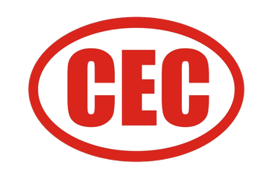
CEC has played a major role in national infrastructure projects, particularly those funded by international organizations such as the World Bank and Asian Development Bank. Its core services include road and highway construction, drainage and bridge works, earthworks, and asphalt production and paving. With a team of experienced engineers, technicians, and skilled workers, CEC emphasizes professionalism, adherence to engineering standards, and innovation in project delivery.
Figure 1 : Company Logo
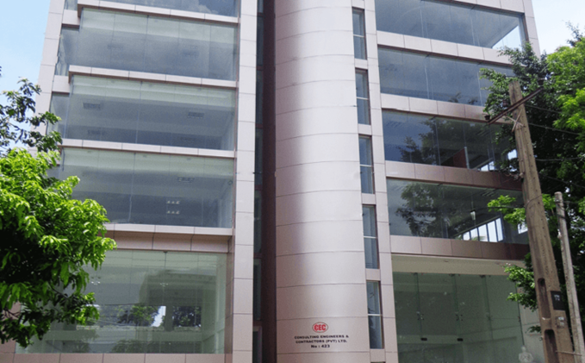
Figure 2 : Head office of CEC
  - Vision and Mission
CEC’s vision is to be a nationally recognized leader in the construction sector, delivering infrastructure that supports economic growth and community well-being. Its mission is to provide reliable, efficient, and environmentally sustainable construction services that meet or exceed client expectations through skilled manpower and modern technology.
  - Organizational Structure
The company operates under a structured hierarchy to ensure smooth communication and accountability. At the top of the structure is the Managing Director, followed by Project Managers, Engineers, Quantity Surveyors, Material Engineers, Site Supervisors, Technicians, and administrative staff.
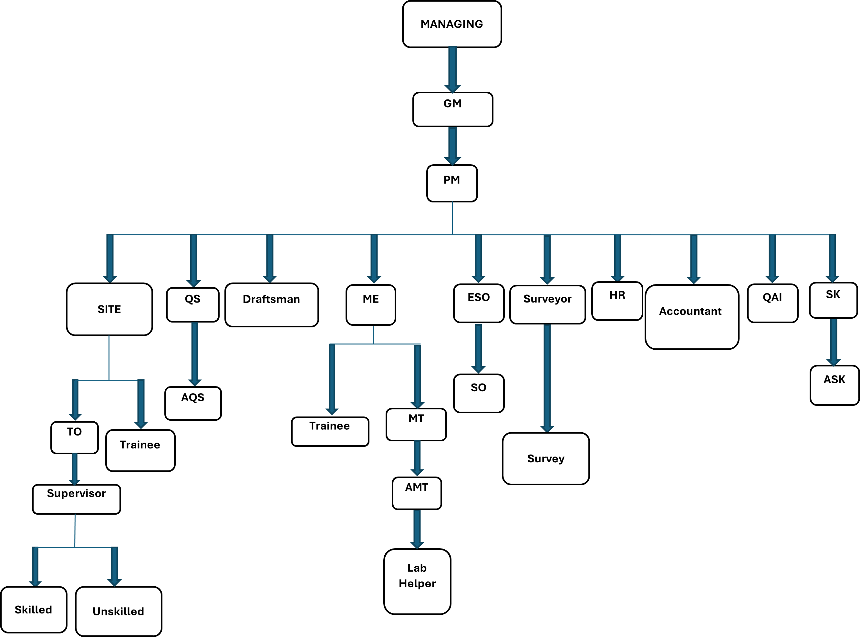
Figure 3 : Organizational Structure of CEC (Pvt) Ltd
Each project typically has a dedicated team that includes a Project Manager, a Site Engineer, a Materials Engineer, and supporting technicians and workers. This structure ensures that all engineering, financial, and administrative functions are efficiently managed.
  - Company Facilities and Equipment
CEC maintains its own fleet of construction equipment, testing laboratories, and asphalt plants. The company’s material laboratory is equipped to conduct all standard geotechnical and construction material tests, including soil classification, compaction tests, concrete and asphalt testing, and quality assurance analysis.
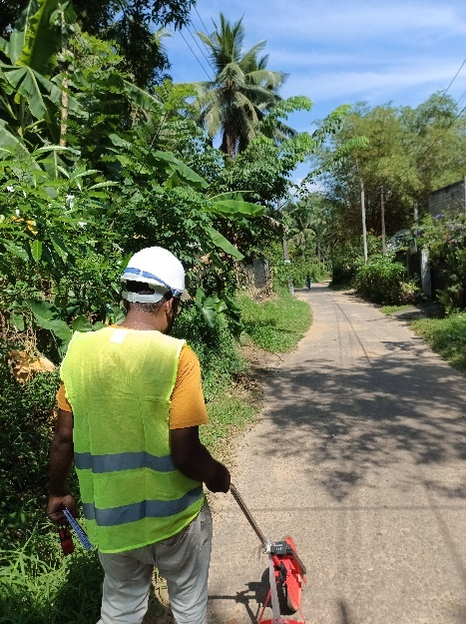
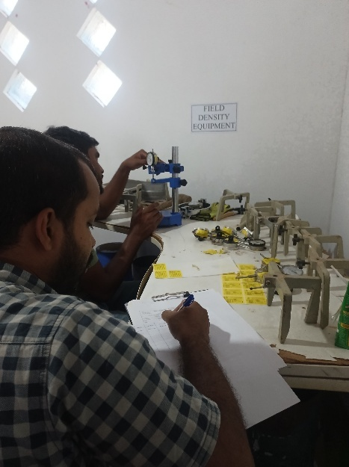
These facilities play a vital role in ensuring material compliance and construction quality across all project phases. The ability to carry out in-house testing gives the company more control over quality and reduces delays associated with third-party testing.
Figure 4 : Laboratory equipment calibrating
Figure 5 : Laboratory Equipment Used for Material Testing at CEC

  - Project Portfolio
CEC has completed numerous projects across Sri Lanka. These include rural road development, national highways, and urban infrastructure. One of the significant ongoing projects is the Inclusive Connectivity & Development Project (ICDP) in Homagama, funded by the World Bank. Under this project, CEC was awarded four road segments (lots), with the goal of upgrading and rehabilitating existing rural roads to improve accessibility, safety, and economic connectivity.
I was assigned to Lot 1,2,3,4 – COL/All. The scope of this lot included subgrade preparation, embankment construction, sub-base and base layer placement, asphalt paving, and related quality control testing.
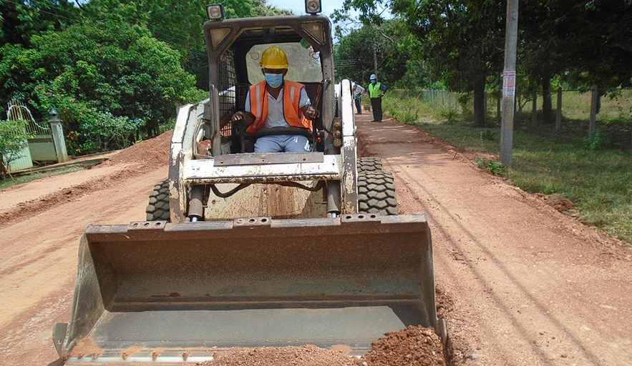
Figure 6 : Road Rehabilitation Work - 1

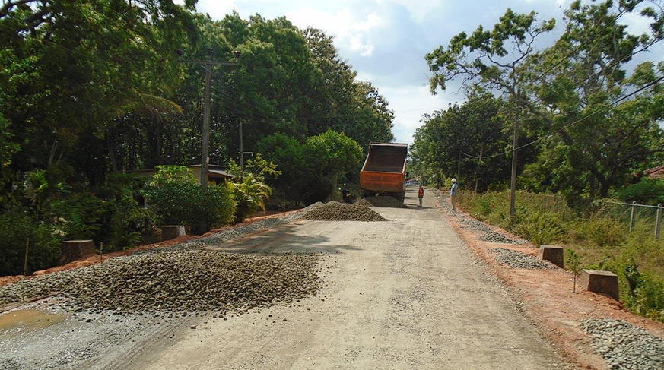
Figure 7 : Road Rehabilitation Work - 2

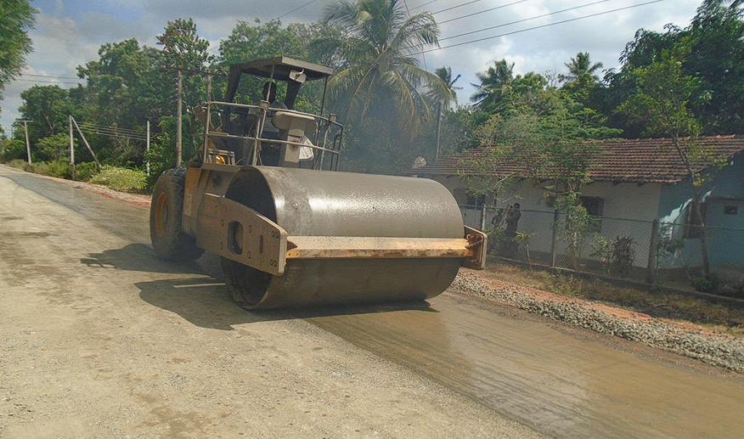
Figure 8 : Road Rehabilitation Work - 3
  - Health, Safety, and Environmental (HSE) Policy
CEC has a strong HSE policy aimed at ensuring worker safety, environmental protection, and compliance with national regulations. The company regularly conducts safety training for its workers and ensures the use of personal protective equipment (PPE) at all job sites. Environmental controls such as proper disposal of waste materials, erosion control, and dust suppression are actively implemented.
The company’s HSE culture also encourages reporting of incidents and near misses to improve workplace practices and reduce risks.
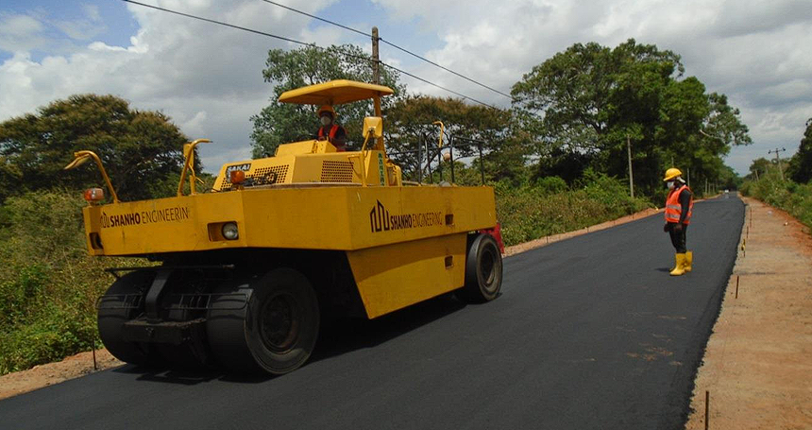
Figure 9 : Safety Measures Implemented at Site - 1
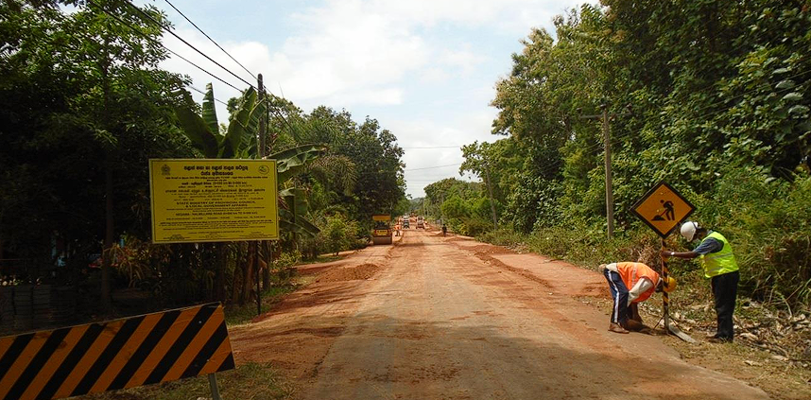
Figure 10 : Safety Measures Implemented at Site - 2
- Familiarization Work & Experiences
  - Initial Familiarization & Support Systems
At the beginning of the internship, I was introduced to the operational environment of Consulting Engineering and Contractors (Pvt) Ltd (CEC) and the Sri Lanka Road Development Authority (RDA)-funded rural road construction project in Homagama. This initial stage helped me understand the project framework, team structure, site practices, and the core systems that support construction operations.
    - Orientation and Site Introduction
During the first week, I participated in the orientation process at the site office, where I was introduced to the main project team, including the Site Engineer, Material Engineer, Quantity Surveyor, and Lab Technicians. I was also briefed on the project scope, which involved the rehabilitation of approximately 4.7 kilometers of rural road under Lot 2 – COL/2.
I was provided with access to technical documents, including:
- ICTAD Specifications (SCA/4, SCA/5, and SCA/8)
- Project-specific requirements from RDA and the supervising consultant
- Method statements for testing and construction processes
- Drawings and contract documents
These materials helped me gain an understanding of engineering practices, site safety requirements, and the workflow expected by both the contractor and the client.
    - Exposure to Internal Systems
      - Health, Safety, and Environment (HSE)
Safety was a key priority from the first day. I was trained on the importance of wearing Personal Protective Equipment (PPE), attending safety briefings, and reporting unsafe conditions or near misses. Toolbox meetings were held daily before fieldwork. I also observed practices such as:
- Clear site demarcation using safety signage
- Dust suppression during excavation
- Safe material handling and storage
These practices follow standard RDA and ICTAD guidelines and aim to reduce risks on-site.
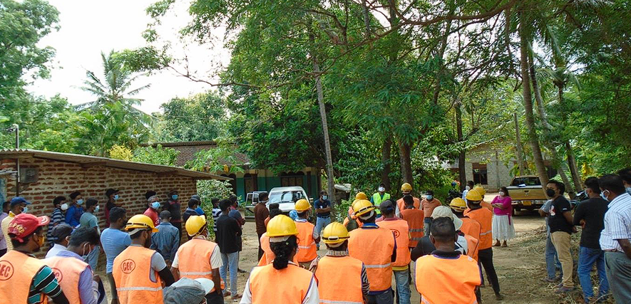
Figure 11 : Morning Safety Briefing at the Site - 1
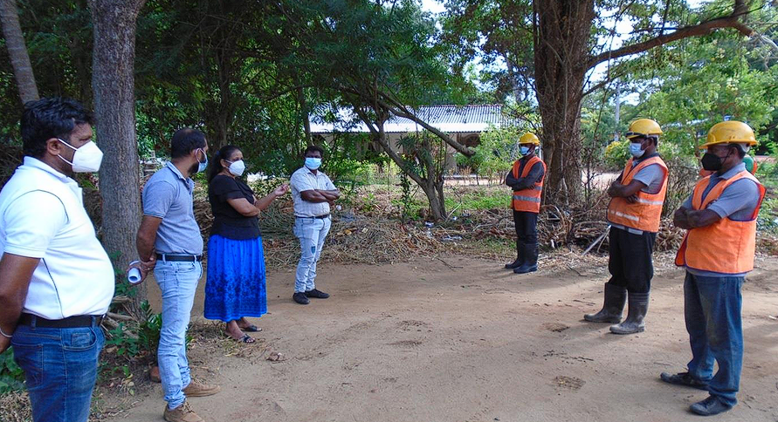
Figure 12 : Morning Safety Briefing at the Site - 2
      - Logistics and Administration
I gained exposure to the logistics processes such as:
- Managing materials delivered to the site
- Preparing gate passes and material inspection forms
- Organizing soil bags and sample tracking sheets for lab testing
The administration team also kept detailed records of Daily Progress Reports (DPRs), Request for Inspections (RFIs), and contractor-client communication. I reviewed these documents to understand the flow of approval and inspection.
      - Laboratory Equipment Calibration
Before conducting any material testing, it was critical to ensure that lab equipment was properly calibrated. Under the supervision of the Material Engineer, I learned how to:
- Calibrate balance scales, ovens, and compaction molds
- Maintain records of calibration logs
- Check condition of sieves and molds regularly
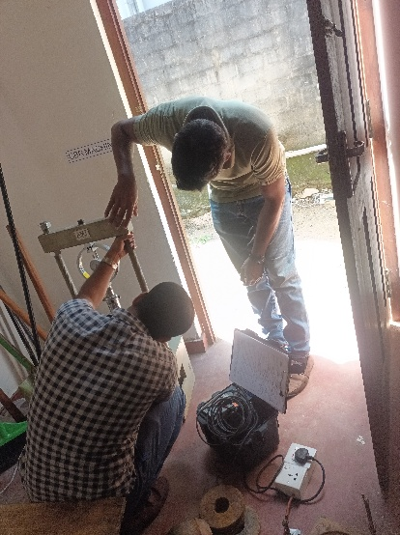
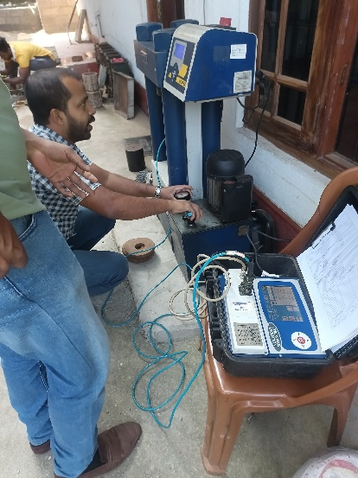
Proper calibration ensures accuracy and consistency in lab results, which is essential for quality assurance in road construction.
Figure 13 : Technician Demonstrating Equipment- 2
Figure 14 : Technician Demonstrating Equipment - 1

    - Familiarization with Field Testing Procedures
In this phase, I was introduced to basic site investigation tests, particularly:
- Dynamic Cone Penetration (DCP) Test
- Test pit excavation and soil bag collection
The DCP test helped assess subgrade strength. I learned how to:
- Record blows and penetration depths
- Calculate CBR values from DCP index
- Prepare manual summary sheets
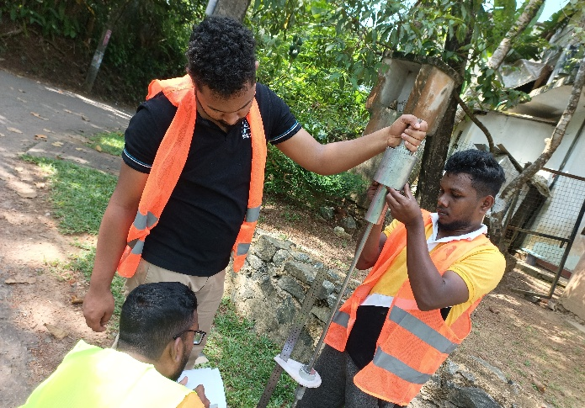
Later, I assisted in developing an automated Excel workbook for DCP data entry and report generation, which increased efficiency and accuracy in field documentation.
Figure 15 : Performing the DCP Test
This familiarization phase was critical in building a strong foundation for the rest of my training. It helped me understand the systems, documentation, safety culture, and testing methods that support successful project delivery in a real construction environment. It also gave me the confidence to take on more technical responsibilities in the following stages of the internship.
  - Technical Work and Hands-on Training
This part of the internship covered the core technical and practical activities involved in road construction and quality assurance. During this period, I had the opportunity to work closely with the Material Engineer, Site Engineers, and Laboratory Technicians to perform various tests, manage materials, and ensure that construction followed the required engineering standards. The experience was mainly focused on field investigations, laboratory testing, mix design verification, and day-to-day construction monitoring.
    - Soil Investigations and Testing
The foundation of any road construction project lies in the quality of the soil. I actively participated in subgrade evaluations and soil testing, particularly:
- Dynamic Cone Penetration (DCP) tests for estimating in-situ CBR values
- Proctor Compaction Test to determine OMC and MDD
- Sieve Analysis and Plasticity Index (PI) tests to classify soils (AASHTO and USCS)
- California Bearing Ratio (CBR) test in both soaked and unsoaked conditions
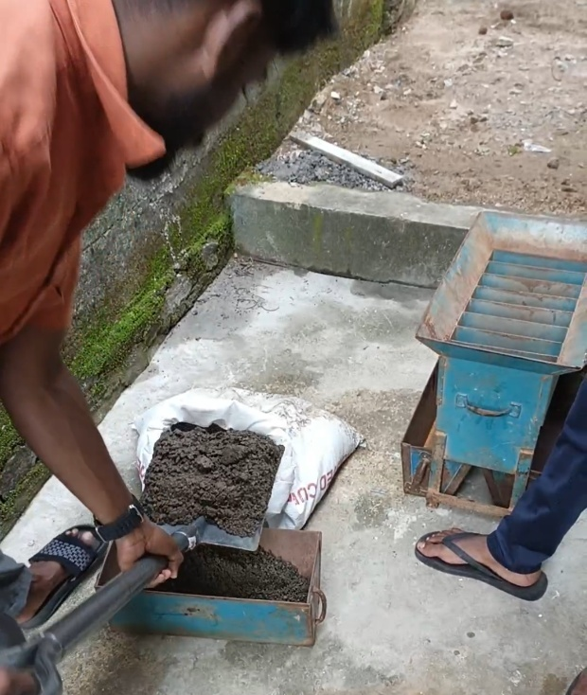
I learned to prepare soil samples, conduct field sampling procedures, and assist in the preparation of laboratory reports under the guidance of the lab technician. These activities helped me understand the correlation between soil properties and pavement performance.
Figure 16 : Preparing Soil Samples for Standard Proctor Test

    - Material Management and Sourcing
I was also exposed to the selection and approval process for road construction materials such as:
- ABC (Aggregate Base Course)
- Quarry dust and crusher-run
- River sand and metal aggregates
- Asphaltic materials
Key activities included:
- Verification of material stockpiles
- Monitoring moisture content at stock yards
- Assisting in sample collection for approvals
These tasks helped me appreciate the importance of material compliance with ICTAD standards and the logistics behind sourcing and delivery.
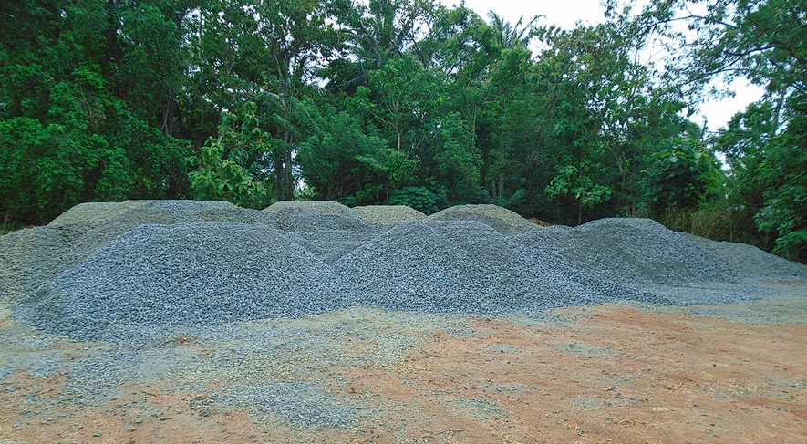
Figure 17 : Stockpile Verification and Sampling at Site - 1
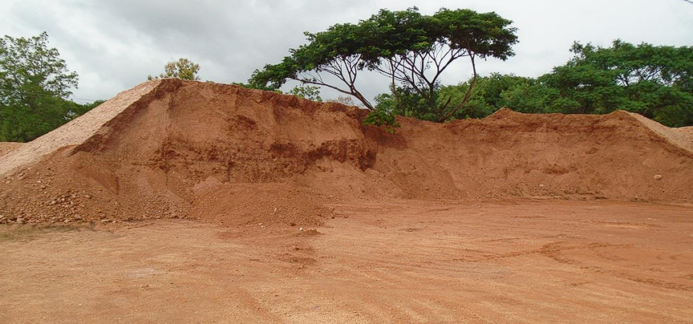
Figure 18 : Stockpile Verification and Sampling at Site - 2

    - Asphalt and Concrete Mix Design
One of the most technically enriching parts of my training was learning about asphalt and concrete mix designs. I worked with the Material Engineer and lab team to:
- Prepare asphalt mix specimens using the Marshall Method
- Conduct Marshall Stability and Flow tests
- Calculate VMA, VFA, and air void content
- Participate in trial mix production and plant inspections
In terms of concrete, I was involved in:
- Slump testing
- Casting and curing of cube samples
- Compression strength testing after 7 and 28 days
These tests were critical for verifying mix consistency and performance.
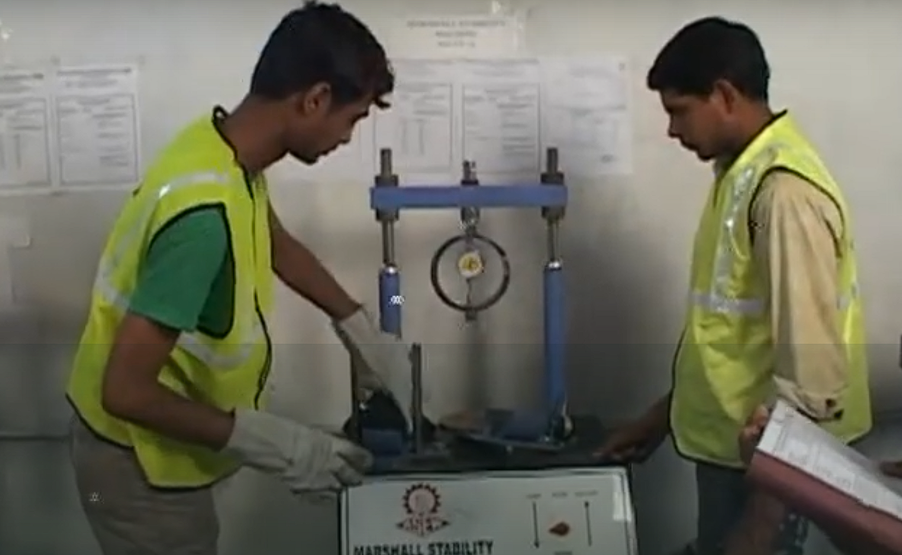
Figure 19 : Performing Marshall Stability Test for Asphalt Mix Evaluation

    - Quality Control and Site Compaction Testing
On-site quality assurance was a daily routine. I was tasked with:
- Monitoring sub-base and base layer compaction
- Performing Field Density Tests (Sand Cone Method)
- Verifying compaction against MDD values
- Supporting engineers in backfilling inspections and RFI preparation
I also learned how to document test results and integrate them into QA reports for consultant review.
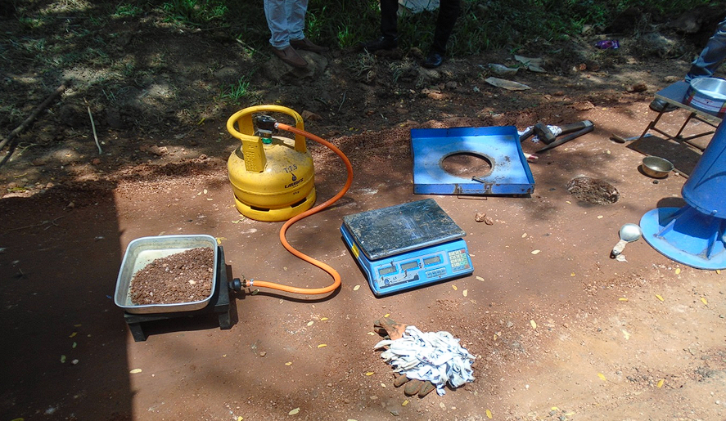
Figure 20 : Field Density Test Using Sand Cone Method
    - Bitumen and Aggregate Testing
In the lab, I supported the testing of key pavement materials. For bitumen, tests included:
- Penetration and softening point
- Specific gravity
- Ductility and flash point
For aggregates, I helped conduct:
- Aggregate Impact Value (AIV)
- Flakiness and Elongation Index (FI & EI)
- Aggregate Crushing Value (ACV)
This hands-on training gave me a strong understanding of the role of material characteristics in durability and performance.
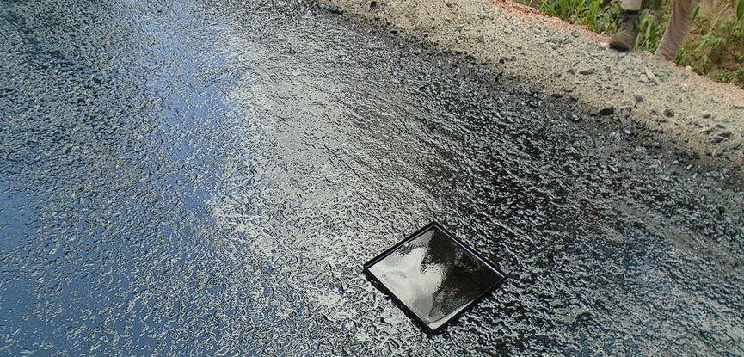
Figure 21 : Measuring Penetration of Bitumen Sample at Lab
    - Daily Engineering Routines
My daily duties typically included:
- Assisting with sample preparation and field inspections
- Preparing and organizing lab result sheets
- Supporting the QA/QC team in data entry and reporting
- Attending site progress meetings and safety briefings
These experiences not only strengthened my technical skills but also improved my work discipline, time management, and ability to work within multidisciplinary teams.
  - Soft Skills, Documentation & SWOT Analysis
Throughout the internship, I had the opportunity not only to develop technical capabilities but also to enhance professional soft skills and participate in documentation and quality assurance practices, which are vital in any engineering environment.

    - Communication and Collaboration
Working on a multidisciplinary team consisting of engineers, supervisors, technicians, and laborers helped me develop better communication and teamwork skills. I regularly participated in:
- Site coordination meetings and toolbox talks
- Discussions with the Materials Engineer and Consultant's representative
- Clarification meetings regarding RFI submissions and approvals
Through these interactions, I improved my ability to convey technical information clearly and learned how to adjust communication styles based on the audience (e.g., supervisors vs. technicians).
Additionally, I learned the importance of active listening, respecting diverse opinions, and providing constructive feedback, especially when coordinating daily testing plans or site work priorities.
    - Use of Digital Tools and Documentation
As part of quality assurance and engineering documentation, I was given tasks that involved using modern tools and systems such as:
- Microsoft Excel: I developed and used automated spreadsheets to streamline test data entry (e.g., DCP results, compaction test summaries, moisture content logs). Functions such as VLOOKUP, conditional formatting, and data validation were useful.
- Word & PDF Editors: Assisted in preparing formal test reports, method statements, and DPRs.
- Digital Camera/Phone Tools: Helped document site progress and material stockpiles with GPS-tagged photos.
I also gained exposure to the Request for Inspection (RFI) process, understanding the typical workflow:
- Preparing the RFI with reference to contract items and specifications
- Coordinating the consultant's inspection
- Logging inspection outcomes and approvals/rejections
This experience gave me valuable insight into the flow of quality control and compliance within large-scale construction projects.
    - Self SWOT Analysis
Performing a SWOT analysis helped me reflect on my personal and professional development during the internship.
Strengths:
- Strong grasp of material testing procedures
- Fast learner with Excel/data handling
- Willingness to work under field/lab conditions
- Positive attitude and discipline
Weaknesses:
- Initial lack of field confidence
- Limited knowledge of construction workflow
- Hesitation in decision-making during early weeks

Opportunities:
- Exposure to real-world infrastructure projects
- Mentorship from experienced engineers
- Improving both technical and interpersonal skills
Threats:
- High-pressure environment with tight deadlines
- Possibility of making mistakes due to inexperience
- Need for continuous self-learning to stay relevant
This exercise helped me recognize areas for growth while reinforcing my strengths.
    - Organizational SWOT Analysis
In addition to analyzing myself, I also evaluated the organization based on my observations.
Strengths:
- Well-established reputation in road construction
- Skilled workforce and dedicated materials lab
- Strong adherence to quality control and safety standards
Weaknesses:
- Occasional delays in procurement and approvals
- Over-dependence on manual documentation
Opportunities:
- Adoption of digital project management systems
- Expansion into urban and high-speed road projects
Threats:
- Regulatory changes or funding delays from clients
- Rising material costs and workforce availability
This SWOT analysis offered a better understanding of CEC's operational landscape and strategic challenges.
- Conclusion
  - Reflection on Internship Experience
The internship at Consulting Engineering and Contractors (Pvt) Ltd (CEC) offered me a transformative opportunity to apply my academic knowledge to real-world engineering practices. Over the 24-week training period, I was exposed to a wide spectrum of technical, managerial, and personal development experiences. From soil testing and asphalt design to report generation and stakeholder communication, each activity broadened my understanding of how a construction project functions from concept to execution.
Working in both field and laboratory settings gave me firsthand experience in quality control procedures and the importance of adhering to standards such as ICTAD and RDA guidelines. I developed a clearer perspective on how engineering decisions impact safety, efficiency, and cost. Moreover, witnessing the day-to-day interactions among engineers, technicians, and workers enhanced my soft skills, especially in communication and teamwork.
  - Areas for Improvement in the Internship Process
While the internship was largely successful, there are areas that could be improved to enhance the learning outcomes for future trainees:
- Structured Orientation: A more formalized orientation schedule would help trainees adapt more quickly. Though I received adequate initial guidance, a structured training manual or daily plan would make the transition smoother.
- Mentorship Assignment: Assigning each intern a dedicated mentor (e.g., Site Engineer or Material Engineer) could streamline knowledge transfer and help resolve doubts more efficiently.
- Rotational Exposure: Enabling interns to rotate through different departments such as surveying, estimation, and procurement would offer a more holistic understanding of the project cycle.
- Access to Digital Tools: Increased exposure to construction management software such as AutoCAD Civil 3D, Primavera, or project management tools would provide valuable industry skills.
  - Self-Assessment and Growth
Personally, I experienced significant growth during this internship. I became more confident in performing technical tests, managing documentation, and interacting with professionals at different levels. Initially hesitant in decision-making, I gradually took more responsibility and contributed to quality assessments and troubleshooting.
The hands-on training refined my practical engineering judgment and strengthened my interest in infrastructure development. I now have a clearer career direction and am better prepared to handle the responsibilities of a graduate engineer in the construction sector.
This internship has not only enriched my academic learning but has also shaped my professional mindset, emphasizing discipline, safety, collaboration, and continuous learning. I am grateful for this experience and look forward to applying these lessons in my future career.

- References

[1] Consulting Engineers & Contractors (Pvt) Ltd. CEC: Consulting Engineers and Contractors - Official Website. [Online]. Available: https://www.cec.lk/. [Accessed: Jul. 20, 2025].

